PART I DATA

1 The Production

Company Akram Khan Company
Show bahok
Director Akram Khan
Set designer Fabiana Piccioli/Sander Loonen/Akram Khan
Lighting designer Fabiana Piccioli

Sound designer Sander Loonen
Costume designer Tony Aaron Wood
Producer Van Baasbank & Baggerman
Date
Theatre

2 The Theatre

Name of the theatre
Address
Postal code & city
General phone number
General fax number
General e-mail address
Technical phone number

Technical fax number
Technical e-mail address

Contacts:
General management
Technical management
General RAI responsible
RAI responsible on stage

3 The Company

Name of the company Akram Khan Company
Address unit 323 35 brittania row
Postal code & city London N1 8QH
Country of residence United Kingdom
General phone number +44 (0)20 7354 4333
General fax number +44 (0) 20 7354 5554
General e-mail address office@akramkhancompany.net
Technical phone number +447914715987
Technical fax number +44 (0) 20 7354 5554
technical e-mail address technical@akramkhancompany.net
Mobile phone on tour +447914715987
Contacts:
General management
Technical management Fabiana Piccioli
Production management Bia Oliveira Jenkins
Stage manager on tour Richard Fagan
Rigging engineer on tour Richard Fagan
Lighting engineer on tour Richard Fagan
Sound engineer on tour t.b.a.
General RAI responsible Fabiana Piccioli
RAI responsible on tour Richard Fagan

4 The Producer

Name of the producer Van Baasbank & Baggerman
Address Keizersgracht 258
Postal code & city 1016 EV Amsterdam
General phone number 020-6242631
General fax number 020-6227850
General e-mail address info@baasbank-baggerman.nl
Technical phone number 06-50267679
Technical fax number 030-2948401
Technical e-mail address marijcke@baasbank-baggerman.nl
Contacts:
General management Jaap van Baasbank
Production management JG Baggerman
Technical management Marijcke Voorsluijs
Stage manager on tour Dennis Wevers
General RAI responsible Marijcke Voorsluijs
RAI responsible on tour Dennis Wevers

PART II RESPONSIBILITIES

1 The Theatre
- Knowledge of risk assessment and safety regulations, shown in a general Risk Assessment Inventory (in Dutch: RI&E).
- Practise of this knowledge at the workplace.
- Responsible behaviour of technicians employed or hired by the theatre.
- Safety education of technicians employed or hired by the theatre.
- Appropriate personal protective equipment for technicians employed by the theatre.
- Safety on stage in general.
- Safety, certification and maintenance of house materials and utensils.
- Safe operation of the theatre's installations.
- Safety of materials rented by the theatre.
- Contact with local fire department to obtain permits for fire effects, based on information provided by the company through the producer.
- Working schedule for technicians employed or hired by the theatre, based on agreements between company and theatre, in accordance with the Dutch working hours regulations.

2 The Company
- Knowledge of risk assessment and safety regulations valid in the Netherlands.
- Practise of this knowledge at the workplace.
- Responsible behaviour of technicians employed or hired by the company.
- Safety education of technicians employed or hired by the company.
- Correct, appropriate and complete information about the safety aspects of the production for the producer and the theatre.
- Appropriate safety instructions for house technicians about the company's materials, during setup, rehearsal, show and strike
- Appropriate personal protective equipment for company technicians, and for house technicians if necessary for handling company materials or installations.
- Safety, certification and maintenance of all company materials and utensils used on tour.
- Safe operation of company installations.
- Safety of materials rented by the company.
- Working schedule for technicians employed or hired by the company in accordance with the Dutch working hours regulations.

3 The Producer
- Knowledge of risk assessment and safety regulations valid in the Netherlands.
- Practise of this knowledge at the workplace.
- Correct, appropriate and complete information about the standards, rules and regulations in the Netherlands.
- Correct, appropriate and complete information about the safety aspects of the production to the theatre, based on information provided by the company.
- Work permits for company members.
- Adequate tour planning as to enable the company to schedule its members in accordance with the Dutch working hours regulations.
- Responsible behaviour of technicians employed or hired by the producer.
- Safety education of technicians employed or hired by the producer.
- Appropriate personal protective equipment for technicians employed by the producer.
- Safety of materials owned or rented by the producer.
- Working schedule for technicians employed or hired by the producer in accordance with the Dutch working hours regulations.

PART III CHECKLIST
Does the company carry an appropriate First Aid Kit for those who work on stage? from the theatre, please
Is safety for the technicians being monitored with relation to:
- unhealthy low or high temperatures? indoor performance
Is personal protective equipment being provided and used? technicians wear safety shoes
Does the company carry an appropriate First Aid Kit for those who work on the show? first aid for dancers available
Is safety for the artists being taken into account with relation to:
- trapping, tripping, falling and slipping? cables are taped
- sound levels high enough to damage hearing? sound technician to be seated in auditorium
- fire or explosion? no such equipment
Is safety information being given to the audience about specific risks or hazards? no specific risks for audience
Is working at heights avoided during setup and strike? only focusing lights
Are the persons who work at heights qualified to do so? (specify qualification) experienced technicians
Has the set been constructed by qualified persons? (specify in last column) set is made by Pieter Muller (NL)
Has overhead rigging of the set been avoided? one set piece is rigged
Has overhead rigging of heavy weights been avoided? (weight of heaviest points in last column) max 60 Kg
Have safety measures been taken to protect persons during fly movements of the set? no fly movements during the show
Does rental lighting equipment come from a professional company? (specify in last column) Flashlight
Does sound equipment brought by the company meet international safety standards? CE certified
Has the use of smoke been avoided? rented hazer

PART IV SIGNATURES
The theatre declares
- to accept the responsibilities described in part II of this document
- to have read and accepted the information given in part I and III

The company declares
- to accept the responsibilities described in part II of this document
- to have given complete and correct information in part I and III is
- that the information is given by persons with ample knowledge of safety and risk assessment at the workplace.

The producer declares
- to accept the responsibilities described in part II of this document
- to have read and accepted the information given in part I and III

The theatre The company The producer
Name Name Fabiana Piccioli Name Marijcke Voorsluijs
Date Date Date 24 augustus 2008
Signature Signature Signature
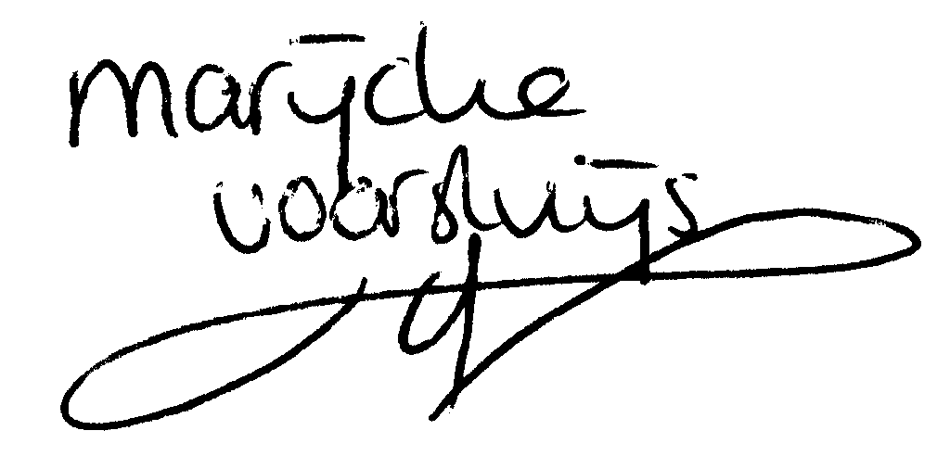

© Marijcke Voorsluijs for Van Baasbank & Baggerman (Thanks to Stadsschouwburg Utrecht and Het Muziektheater), June 2002
Reproduction and use of this document is authorized, provided the source is acknowledged and the writer informed
Comments are always greatly appreciated! Please send an e-mail to marijcke@totheater.nl

