PART I DATA

1 The Production

Company Zic Zazou
Show Obstinato
Director Jean-François Hoël
Set designer
Lighting designer Gilles Robert

Sound designer Jean-Luc Mallet
Costume designer
Producer Van Baasbank & Co
Date
Theatre

2 The Theatre

Name of the theatre
Address
Postal code & city
General phone number
General fax number
General e-mail address
Technical phone number

Technical fax number
Technical e-mail address

Contacts:
General management
Technical management
General RAI responsible
RAI responsible on stage

3 The Company

Name of the company Zic Zazou
Address 95 rue des Quatre Lemaire
Postal code & city 80000 AMIENS
Country of residence France
General phone number 03 22 89 11 22
General e-mail address sicalines@wanadoo.fr
Technical phone number +33 148032280
technical e-mail address camaieublafard@wanadoo.fr
Mobile phone on tour +33 681435487

Contacts:
General management Stephanie CARPENTIERl
Technical management Gilles Robert
Production management Michel Berte
Stage manager on tour Gilles Robert
Rigging engineer on tour Gilles Robert
Lighting engineer on tour Gilles Robert
Sound engineer on tour Jean-luc Mallet
General RAI responsible Michel Berte
RAI responsible on tour Gilles Robert

4 The Producer

Name of the producer Van Baasbank & Co
Address Keizersgracht 258
Postal code & city 1016 EV Amsterdam
General phone number 020-6242631
General fax number 020-6227850
General e-mail address info@baasbank-co.nl
Technical phone number 06-50267679
Technical fax number 020-6227850
Technical e-mail address marijcke@baasbank-co.nl
Contacts:
General management Jaap van Baasbank
Production management Dick Vos
Technical management Marijcke Voorsluijs
Stage manager on tour Bart van Geldrop
General RAI responsible Marijcke Voorsluijs
RAI responsible on tour Bart van Geldrop

PART II RESPONSIBILITIES

1 The Theatre
- Knowledge of risk assessment and safety regulations, shown in a general Risk Assessment Inventory (in Dutch: RI&E).
- Practise of this knowledge at the workplace.
- Responsible behaviour of technicians employed or hired by the theatre.
- Safety education of technicians employed or hired by the theatre.
- Appropriate personal protective equipment for technicians employed by the theatre.
- Safety on stage in general.
- Safety, certification and maintenance of house materials and utensils.
- Safe operation of the theatre's installations.
- Safety of materials rented by the theatre.
- Contact with local fire department to obtain permits for fire effects, based on information provided by the company through the producer.
- Working schedule for technicians employed or hired by the theatre, based on agreements between company and theatre, in accordance with the Dutch working hours regulations.

2 The Company
- Knowledge of risk assessment and safety regulations valid in the Netherlands.
- Practise of this knowledge at the workplace.
- Responsible behaviour of technicians employed or hired by the company.
- Safety education of technicians employed or hired by the company.
- Correct, appropriate and complete information about the safety aspects of the production for the producer and the theatre.
- Appropriate safety instructions for house technicians about the company's materials, during setup, rehearsal, show and strike
- Appropriate personal protective equipment for company technicians, and for house technicians if necessary for handling company materials or installations.
- Safety, certification and maintenance of all company materials and utensils used on tour.
- Safe operation of company installations.
- Safety of materials rented by the company.
- Working schedule for technicians employed or hired by the company in accordance with the Dutch working hours regulations.

3 The Producer
- Knowledge of risk assessment and safety regulations valid in the Netherlands.
- Practise of this knowledge at the workplace.
- Correct, appropriate and complete information about the standards, rules and regulations in the Netherlands.
- Correct, appropriate and complete information about the safety aspects of the production to the theatre, based on information provided by the company.
- Work permits for company members.
- Adequate tour planning as to enable the company to schedule its members in accordance with the Dutch working hours regulations.
- Responsible behaviour of technicians employed or hired by the producer.
- Safety education of technicians employed or hired by the producer.
- Appropriate personal protective equipment for technicians employed by the producer.
- Safety of materials owned or rented by the producer.
- Working schedule for technicians employed or hired by the producer in accordance with the Dutch working hours regulations.

PART III CHECKLIST
Does the company carry an appropriate First Aid Kit for those who work on stage? from the theatre
Is safety for the technicians being monitored with relation to:
- unhealthy low or high temperatures? indoor performances
- fire or explosion? no fire
Is personal protective equipment being provided and used? technicians wear safety shoes
Is safety for the artists being taken into account with relation to:
- trapping, tripping, falling and slipping? cables are taped
- fire or explosion? a grinder (slijptol) is used in one scene by an actor with safety glasses; wet cloth or fire extinguisher on site, from the theatre please
Is safety for the audience being taken into account with relation to:
- movements of parts or material which may result in a person being hit? no objects placed in auditorium
Is working at heights avoided during setup and strike? Just focusing lights, genie from theatre
Is working at heights avoided during rehearsal and show? Done by people of the theater
Has the set been constructed by qualified persons? (specify in last column) the artists themselves
Has the use of electricity on the set been avoided? small light in the set
Are regular checks performed on the electrical parts?
Has overhead rigging of the set been avoided? 1 object is flown with rope/pullies, 35kg
Are the persons who do the overhead rigging qualified to do so? (specify qualification) Experienced stage technician
Have fly movements of the set been avoided? 1 object is flown with rope/pullies, 35kg
Have safety measures been taken to protect persons during fly movements of the set? actors know the cues
Has protection of the artists been taken into account in the choice or construction of the props? actor wears protective glasses when using the grinder
Does rental lighting equipment come from a professional company? (specify in last column) Flashlight
Does rental sound equipment come from a professional company? (specify in last column) WG Theatertechniek
Has the use of smoke been avoided? rented hazer
Has the use of other special effects been avoided? grinder used ; wet cloth or fire extinguisher on site, from the theatre please
Are measures being taken to perform the special effects in a safe way? actor wears safety glasses

PART IV SIGNATURES
The theatre declares
- to accept the responsibilities described in part II of this document
- to have read and accepted the information given in part I and III

The company declares
- to accept the responsibilities described in part II of this document
- to have given complete and correct information in part I and III is
- that the information is given by persons with ample knowledge of safety and risk assessment at the workplace.

The producer declares
- to accept the responsibilities described in part II of this document
- to have read and accepted the information given in part I and III

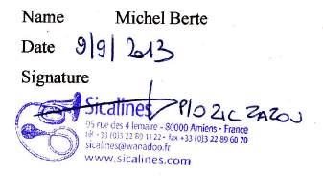
The theatre The company The producer
Name Name Michel Berte Name Marijcke Voorsluijs
Date Date Date 30 augustus 2013
Signature Signature Signature
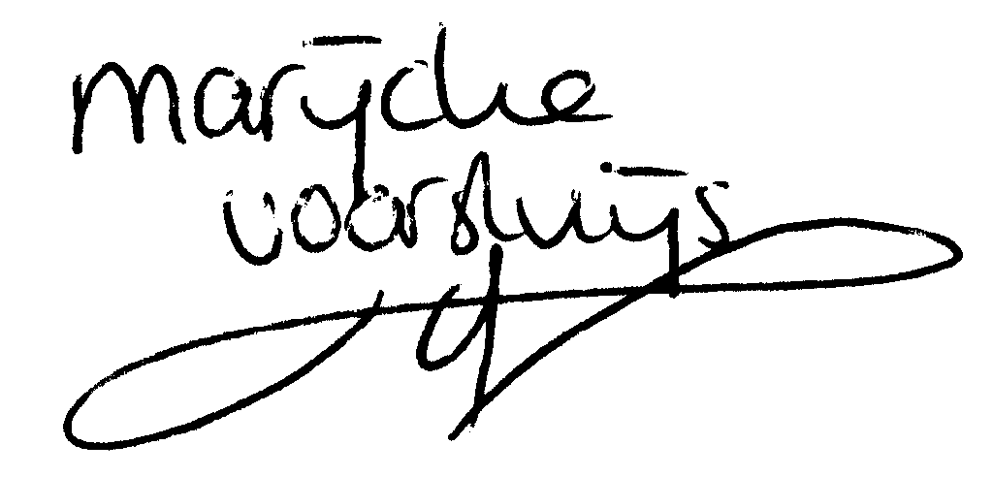
© Marijcke Voorsluijs for Van Baasbank & Baggerman (Thanks to Stadsschouwburg Utrecht and Het Muziektheater), June 2002
Reproduction and use of this document is authorized, provided the source is acknowledged and the writer informed
Comments are always greatly appreciated! Please send an e-mail to marijcke@totheater.nl

