PART I DATA

1 The Production

Company Jo Strømgren Kompani
Show A Dance Tribute to Ping Pong
Director Jo Strømgren
Set designer N/A
Lighting designer Stephen Rolfe

Sound designer Lars Årdal, Audun Melbye
Costume designer Jo Strømgren
Producer Van Baasbank & Co
Date
Theatre

2 The Theatre
Name of the theatre
Address
Postal code & city
General phone number
General e-mail address
Technical phone number
Technical e-mail address
Contacts:
General management
Technical management
General RAI responsible
RAI responsible on stage

3 The Company

Name of the company Jo Strømgren Kompani
Address Uranienborg Terrasse 9
Postal code & city 0351 Oslo
Country of residence Norway
General phone number +4722460459
General e-mail address mail@jskompani.no
Technical phone number (+47) 90168766 (S. Rolfe)
technical e-mail address stephenrlf@gmail.com
Mobile phone on tour (+47) 958 13 334 (Eirik B T)
General management Sunniva Steine
Technical management Stephen Rolfe
Production management Sunniva Steine
Stage manager on tour Eirik Brenne Torsethaugen
Rigging engineer on tour Eirik Brenne Torsethaugen
Lighting engineer on tour Eirik Brenne Torsethaugen
Sound engineer on tour Jon Grimsgård
General RAI responsible Sunniva Steine
RAI responsible on tour Eirik Brenne Torsethaugen

4 The Producer

Name of the producer Van Baasbank & Co
Address Keizersgracht 258
Postal code & city 1016 EV Amsterdam
General phone number 020-6242631
General e-mail address info@baasbank-co.nl
Technical phone number 06-50267679
Technical e-mail address marijcke@baasbank-co.nl
General management Jaap van Baasbank
Production management Dick Vos
Technical management Marijcke Voorsluijs
Stage manager on tour Roy Vermeer
General RAI responsible Marijcke Voorsluijs
RAI responsible on tour Roy Vermeer

PART II RESPONSIBILITIES

1 The Theatre
- Knowledge of risk assessment and safety regulations, shown in a general Risk Assessment Inventory (in Dutch: RI&E).
- Practise of this knowledge at the workplace.
- Responsible behaviour of technicians employed or hired by the theatre.
- Safety education of technicians employed or hired by the theatre.
- Appropriate personal protective equipment for technicians employed by the theatre.
- Safety on stage in general.
- Safety, certification and maintenance of house materials and utensils.
- Safe operation of the theatre's installations.
- Safety of materials rented by the theatre.
- Contact with local fire department to obtain permits for fire effects, based on information provided by the company through the producer.
- Working schedule for technicians employed or hired by the theatre, based on agreements between company and theatre, in accordance with the Dutch working hours regulations.

2 The Company
- Knowledge of risk assessment and safety regulations valid in the Netherlands.
- Practise of this knowledge at the workplace.
- Responsible behaviour of technicians employed or hired by the company.
- Safety education of technicians employed or hired by the company.
- Correct, appropriate and complete information about the safety aspects of the production for the producer and the theatre.
- Appropriate safety instructions for house technicians about the company's materials, during setup, rehearsal, show and strike
- Appropriate personal protective equipment for company technicians, and for house technicians if necessary for handling company materials or installations.
- Safety, certification and maintenance of all company materials and utensils used on tour.
- Safe operation of company installations.
- Safety of materials rented by the company.
- Working schedule for technicians employed or hired by the company in accordance with the Dutch working hours regulations.

3 The Producer
- Knowledge of risk assessment and safety regulations valid in the Netherlands.
- Practise of this knowledge at the workplace.
- Correct, appropriate and complete information about the standards, rules and regulations in the Netherlands.
- Correct, appropriate and complete information about the safety aspects of the production to the theatre, based on information provided by the company.
- Work permits for company members.
- Adequate tour planning as to enable the company to schedule its members in accordance with the Dutch working hours regulations.
- Responsible behaviour of technicians employed or hired by the producer.
- Safety education of technicians employed or hired by the producer.
- Appropriate personal protective equipment for technicians employed by the producer.
- Safety of materials owned or rented by the producer.
- Working schedule for technicians employed or hired by the producer in accordance with the Dutch working hours regulations.

PART III CHECKLIST
Does the company carry an appropriate First Aid Kit for those who work on stage?
Is safety for the technicians being monitored with relation to:
- fire or explosion? no such material
Is personal protective equipment being provided and used? technicians wear safety shoes
Is safety for the artists being taken into account with relation to:
- trapping, tripping, falling and slipping? cables are taped
- blinding or electrocution of persons? no such material
Is safety for the audience being taken into account with relation to:
- movements of parts or material which may result in a person being hit? no objects placed in auditorium
Is safety information being given to the audience about specific risks or hazards? no specific risks for the audience
Is working at heights avoided during setup and strike? Just focusing lights, genie from theatre
Is working at heights avoided during rehearsal and show?
Has the set been constructed by qualified persons? (specify in last column) No set
Are the costumes flame resistant, or treated with flame retarder? (Only in case of open fire.) no open flame
Does lighting equipment brought by the company meet international safety standards? No such equipment
Does rental lighting equipment come from a professional company? (specify in last column) Flashlight
Does rental sound equipment come from a professional company? (specify in last column) Ampco
Has the use of other special effects been avoided? No special effects

PART IV SIGNATURES
The theatre declares
- to accept the responsibilities described in part II of this document
- to have read and accepted the information given in part I and III

The company declares
- to accept the responsibilities described in part II of this document
- to have given complete and correct information in part I and III is
- that the information is given by persons with ample knowledge of safety and risk assessment at the workplace.

The producer declares
- to accept the responsibilities described in part II of this document
- to have read and accepted the information given in part I and III

The theatre The company The producer
Name Name Stephen Rolfe Name Marijcke Voorsluijs
Date Date 17 January 2014 Date 19 januari 2014
Signature Signature Signature
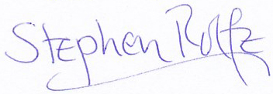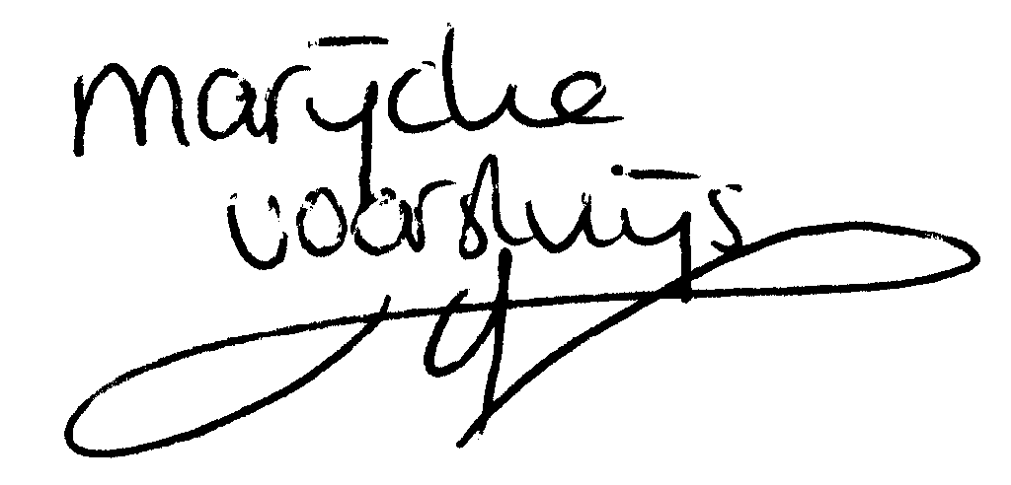
© Marijcke Voorsluijs for Van Baasbank & Baggerman (Thanks to Stadsschouwburg Utrecht and Het Muziektheater), June 2002
Reproduction and use of this document is authorized, provided the source is acknowledged and the writer informed
Comments are always greatly appreciated! Please send an e-mail to marijcke@totheater.nl

