PART I DATA

1 The Production

Company Superamas
Show Empire (Art & Politics)
Director superamas
Set designer superamas
Lighting designer superamas

Sound designer superamas
Costume designer Sabine Desbonnets/Alix Eynaudi
Producer Van Baasbank & Baggerman
Date
Theatre

2 The Theatre

Name of the theatre
Address
Postal code & city
General phone number
General fax number
General e-mail address
Technical phone number

Technical fax number
Technical e-mail address

Contacts:
General management
Technical management
General RAI responsible
RAI responsible on stage

3 The Company

Name of the company Superamas
Address Sensengasse 5/14
Postal code & city A-1090 Vienna
Country of residence Austria
General phone number +4369911592981
General fax number
General e-mail address caro@superamas.com
Technical phone number +436604019436
Technical fax number
technical e-mail address dinuschwab@hotmail.com
Mobile phone on tour +436604019436
Contacts:
General management Caroline Madl
Technical management Martin Schwab
Production management Caroline Madl
Stage manager on tour Martin SCHWAB
Rigging engineer on tour
Lighting engineer on tour Henri Doublier
Sound engineer on tour Olivier TIRMARCHE
General RAI responsible Martin SCHWAB
RAI responsible on tour Martin SCHWAB

4 The Producer

Name of the producer Van Baasbank & Baggerman
Address Keizersgracht 258
Postal code & city 1016 EV Amsterdam
General phone number 020-6242631
General fax number 020-6227850
General e-mail address info@baasbank-baggerman.nl
Technical phone number 06-50267679
Technical fax number 020-6227850
Technical e-mail address marijcke@baasbank-baggerman.nl
Contacts:
General management Jaap van Baasbank
Production management JG Baggerman
Technical management Marijcke Voorsluijs
Stage manager on tour Dennis Wevers
General RAI responsible Marijcke Voorsluijs
RAI responsible on tour Dennis Wevers

PART II RESPONSIBILITIES

1 The Theatre
- Knowledge of risk assessment and safety regulations, shown in a general Risk Assessment Inventory (in Dutch: RI&E).
- Practise of this knowledge at the workplace.
- Responsible behaviour of technicians employed or hired by the theatre.
- Safety education of technicians employed or hired by the theatre.
- Appropriate personal protective equipment for technicians employed by the theatre.
- Safety on stage in general.
- Safety, certification and maintenance of house materials and utensils.
- Safe operation of the theatre's installations.
- Safety of materials rented by the theatre.
- Contact with local fire department to obtain permits for fire effects, based on information provided by the company through the producer.
- Working schedule for technicians employed or hired by the theatre, based on agreements between company and theatre, in accordance with the Dutch working hours regulations.

2 The Company
- Knowledge of risk assessment and safety regulations valid in the Netherlands.
- Practise of this knowledge at the workplace.
- Responsible behaviour of technicians employed or hired by the company.
- Safety education of technicians employed or hired by the company.
- Correct, appropriate and complete information about the safety aspects of the production for the producer and the theatre.
- Appropriate safety instructions for house technicians about the company's materials, during setup, rehearsal, show and strike
- Appropriate personal protective equipment for company technicians, and for house technicians if necessary for handling company materials or installations.
- Safety, certification and maintenance of all company materials and utensils used on tour.
- Safe operation of company installations.
- Safety of materials rented by the company.
- Working schedule for technicians employed or hired by the company in accordance with the Dutch working hours regulations.

3 The Producer
- Knowledge of risk assessment and safety regulations valid in the Netherlands.
- Practise of this knowledge at the workplace.
- Correct, appropriate and complete information about the standards, rules and regulations in the Netherlands.
- Correct, appropriate and complete information about the safety aspects of the production to the theatre, based on information provided by the company.
- Work permits for company members.
- Adequate tour planning as to enable the company to schedule its members in accordance with the Dutch working hours regulations.
- Responsible behaviour of technicians employed or hired by the producer.
- Safety education of technicians employed or hired by the producer.
- Appropriate personal protective equipment for technicians employed by the producer.
- Safety of materials owned or rented by the producer.
- Working schedule for technicians employed or hired by the producer in accordance with the Dutch working hours regulations.

PART III CHECKLIST
Is safety for the technicians being monitored with relation to:
- blinding or electrocution of persons? warning when checking stroboscopes
- fire or explosion? no such material
Is personal protective equipment being provided and used? company to provide steel toes for their crew
Is safety for the artists being taken into account with relation to:
- trapping, tripping, falling and slipping? cables are taped
Is safety for the audience being taken into account with relation to:
- movements of parts or material which may result in a person being hit? no objects placed in auditorium
- blinding or electrocution of persons? 2 x 3000W stroboscopes
Is safety information being given to the audience about specific risks or hazards? venue is to warn audience for stroboscopes
Is working at heights avoided during setup and strike? Just focusing lights, genie from theatre
Has the set been constructed by qualified persons? (specify in last column) Jerome Dupraz/Luc Moreau
Has the use of heavy materials been avoided? (specify weight of heaviest parts in last column) Dolly on wheels, 150kg
Does rental lighting equipment come from a professional company? (specify in last column) Flashlight
Is safety on lighting galleries being monitored? we don't rig lights on the galleries
Does rental sound equipment come from a professional company? (specify in last column) WG Theatertechniek
Has the use of explosions or fireworks been avoided? fake 'fireworks' effect (only lighting)
Are the necessary certificates being carried?
Are the persons who perform the special effects qualified to do so? (specify qualification)

PART IV SIGNATURES
The theatre declares
- to accept the responsibilities described in part II of this document
- to have read and accepted the information given in part I and III

The company declares
- to accept the responsibilities described in part II of this document
- to have given complete and correct information in part I and III is
- that the information is given by persons with ample knowledge of safety and risk assessment at the workplace.

The producer declares
- to accept the responsibilities described in part II of this document
- to have read and accepted the information given in part I and III

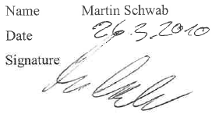
The theatre The company The producer
Name Name Martin Schwab Name Marijcke Voorsluijs
Date Date 26 maart 2010 Date 19 maart 2010
Signature Signature Signature
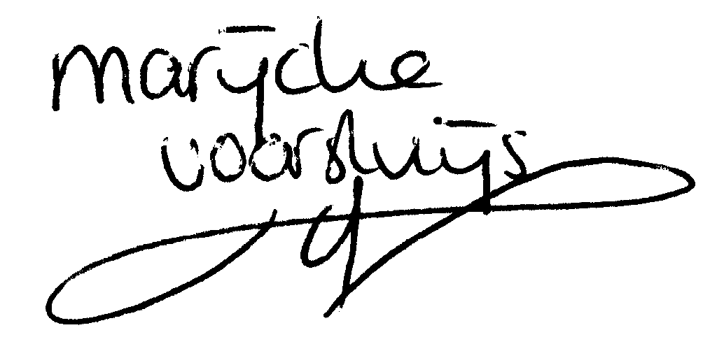
© Marijcke Voorsluijs for Van Baasbank & Baggerman (Thanks to Stadsschouwburg Utrecht and Het Muziektheater), June 2002
Reproduction and use of this document is authorized, provided the source is acknowledged and the writer informed
Comments are always greatly appreciated! Please send an e-mail to marijcke@totheater.nl

