PART I DATA

1 The Production

Company Ultima Vez
Show Monkey Sandwich
Director Wim Vandekeybus
Set designer Wim Vandekeybus and team
Lighting designer Francis Gahide, Wim Vandekeybus

Sound designer Benjamin Dandoy, Antoine Delagoutte
Costume designer N/A
Producer Van Baasbank & Baggerman
Date
Theatre

2 The Theatre

Name of the theatre
Address
Postal code & city
General phone number
General fax number
General e-mail address
Technical phone number

Technical fax number
Technical e-mail address

Contacts:
General management
Technical management
General RAI responsible
RAI responsible on stage

3 The Company

Name of the company Ultima Vez
Address Koolmijnenkaai 34
Postal code & city 1080 Brussels
Country of residence Belgium
General phone number +32 2 219 55 28
General fax number +32 2 219 68 02
General e-mail address contact@ultimavez.com
Technical phone number 0032 473 358264
Technical fax number +32 2 219 68 02
technical e-mail address jitske@ultimavez.com
Mobile phone on tour 0032 473 358264
Contacts:
General management Kristien De Coster
Technical management Jitske Vandenbussche
Production management Isabelle De Cannière
Stage manager on tour Jitske Vandenbussche
Rigging engineer on tour Jitske Vandenbussche
Lighting engineer on tour Nicolas Olivier
Sound engineer on tour Antoine Delagoute
General RAI responsible Jitske Vandenbussche
RAI responsible on tour Jitske Vandenbussche

4 The Producer

Name of the producer Van Baasbank & Baggerman
Address Keizersgracht 258
Postal code & city 1016 EV Amsterdam
General phone number 020-6242631
General fax number 020-6227850
General e-mail address info@baasbank-baggerman.nl
Technical phone number 06-50267679
Technical fax number 020-6227850
Technical e-mail address marijcke@baasbank-baggerman.nl
Contacts:
General management Jaap van Baasbank
Production management JG Baggerman
Technical management Marijcke Voorsluijs
Stage manager on tour N/A
General RAI responsible Marijcke Voorsluijs
RAI responsible on tour N/A

PART II RESPONSIBILITIES

1 The Theatre
- Knowledge of risk assessment and safety regulations, shown in a general Risk Assessment Inventory (in Dutch: RI&E).
- Practise of this knowledge at the workplace.
- Responsible behaviour of technicians employed or hired by the theatre.
- Safety education of technicians employed or hired by the theatre.
- Appropriate personal protective equipment for technicians employed by the theatre.
- Safety on stage in general.
- Safety, certification and maintenance of house materials and utensils.
- Safe operation of the theatre's installations.
- Safety of materials rented by the theatre.
- Contact with local fire department to obtain permits for fire effects, based on information provided by the company through the producer.
- Working schedule for technicians employed or hired by the theatre, based on agreements between company and theatre, in accordance with the Dutch working hours regulations.

2 The Company
- Knowledge of risk assessment and safety regulations valid in the Netherlands.
- Practise of this knowledge at the workplace.
- Responsible behaviour of technicians employed or hired by the company.
- Safety education of technicians employed or hired by the company.
- Correct, appropriate and complete information about the safety aspects of the production for the producer and the theatre.
- Appropriate safety instructions for house technicians about the company's materials, during setup, rehearsal, show and strike
- Appropriate personal protective equipment for company technicians, and for house technicians if necessary for handling company materials or installations.
- Safety, certification and maintenance of all company materials and utensils used on tour.
- Safe operation of company installations.
- Safety of materials rented by the company.
- Working schedule for technicians employed or hired by the company in accordance with the Dutch working hours regulations.

3 The Producer
- Knowledge of risk assessment and safety regulations valid in the Netherlands.
- Practise of this knowledge at the workplace.
- Correct, appropriate and complete information about the standards, rules and regulations in the Netherlands.
- Correct, appropriate and complete information about the safety aspects of the production to the theatre, based on information provided by the company.
- Work permits for company members.
- Adequate tour planning as to enable the company to schedule its members in accordance with the Dutch working hours regulations.
- Responsible behaviour of technicians employed or hired by the producer.
- Safety education of technicians employed or hired by the producer.
- Appropriate personal protective equipment for technicians employed by the producer.
- Safety of materials owned or rented by the producer.
- Working schedule for technicians employed or hired by the producer in accordance with the Dutch working hours regulations.

PART III CHECKLIST
Does the company carry an appropriate First Aid Kit for those who work on stage? Theatre: please provide 1 kg of ice cubes each day available on stage prior the actor’s arrival, and an emergency box available on stage at any moment.
Is safety for the technicians being monitored with relation to:
- unhealthy low or high temperatures? indoor performance
- blinding or electrocution of persons? no such material
Is personal protective equipment being provided and used? technicians wear safety shoes
Is safety for the artists being taken into account with relation to:
- trapping, tripping, falling and slipping? lighting cables are taped
- unhealthy low or high temperatures? A plexi-cube is placed on the middle-axe of the stage. It is very fragile! If it is filled with water (1000liters) it weighs 1TON. The water should be hot, we bring our own boilers but let us know if there are showers nearby the stage. The water needs to be freshly filled before each performance.
- fire or explosion? Yes Fire liquid and smoke is used
Is safety for the audience being taken into account with relation to:
- trapping, tripping, falling and slipping? no objects installed in audience area
- fire or explosion? Yes
Is working at heights avoided during setup and strike? hanging of lights
Is working at heights avoided during rehearsal and show? No actor climbs on a pillar of 2.2m high
Is a safe way to reach the working height being guaranteed? /no genie from the theatre during setup, but no protection for actor during the rehearsal/show
Is (personal) protection being provided and used? N/A
Are the persons who work at heights qualified to do so? (specify qualification) theatre technicians / dancer
Are the necessary certificates being carried?
Has the set been constructed by qualified persons? (specify in last column)
Is the set made of flame resistant material, or treated with flame retarder? screen is fire resistant
Has the use of electricity on the set been avoided? wind machines
Has the use of heavy materials been avoided? (specify weight of heaviest parts in last column) There is one fixed point that carries up to 1000kg: aquarium filled with water. (See stageplan for the position). Loading capacity of the stage floor there: 1000kg/m2. Depending on your stage floor capacity that point needs to be supported from underneath!
Do the parts have their weight indicated on them? company crew gives instructions
Have fly movements of the set been avoided? fly movements during show
Have safety measures been taken to protect persons during fly movements of the set? no movements over the dancer
Has the use of smoke been avoided? During 2’ fire and smoke are ignited in a metal cube ( 57cmtr.H, 25cmtr.B, 1cmtr.thick metal ) and put out in another metal cube filled with sand.
Has the use of open fire been avoided? see above
Has the use of other special effects been avoided? No Water from aquarium sprayed on stage
Has the participation of animals been avoided? There is one fish in the performance: a carp
Are measures being taken to protect the animals? the carp is transported by its owner; as he can only bring a limited amount of water the theatres are to provide a plastic container (50x100x60cm) filled 50/50 with rain water and tap water
Are measures being taken to protect the health of other participants in regard of the animals?

PART IV SIGNATURES
The theatre declares
- to accept the responsibilities described in part II of this document
- to have read and accepted the information given in part I and III

The company declares
- to accept the responsibilities described in part II of this document
- to have given complete and correct information in part I and III is
- that the information is given by persons with ample knowledge of safety and risk assessment at the workplace.

The producer declares
- to accept the responsibilities described in part II of this document
- to have read and accepted the information given in part I and III

The theatre The company The producer
Name Name Kristien De Coster Name Marijcke Voorsluijs
Date Date Date 15 december 2010
Signature Signature Signature
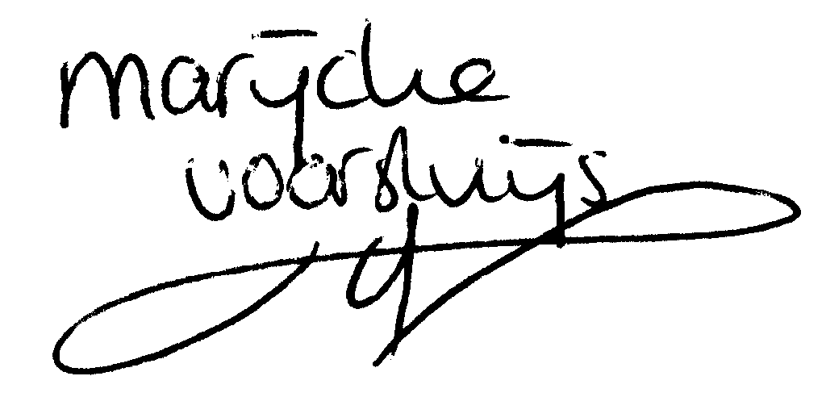

© Marijcke Voorsluijs for Van Baasbank & Baggerman (Thanks to Stadsschouwburg Utrecht and Het Muziektheater), June 2002
Reproduction and use of this document is authorized, provided the source is acknowledged and the writer informed
Comments are always greatly appreciated! Please send an e-mail to marijcke@totheater.nl

